MTECH Unit 7

Software Quality Management
Life-Cycle Activities Assignment

SE 17 Team 4S

1. TENG BOON WEE | HT082246X
2. LI PENGFEI | HT082220L
3. KYAW THU LIN | HT082238Y
4. CAI XIANG | HT082182A
5. NAUNG NAUNG LATT | HT082195L
6. OH CHEW KEY | HT082212M
7. PLATHOTTAM LINU THANKAM | HT082207Y
8. ERIK ARAOJO | HT082194Y

Pre-Contract
The objective of this phase is
- To prepare the documents and tasks that will lead to the signing of the contract.

Input | User Requirements
Output | Initial User Requirement Specifications  Finalized Proposal  Draft Subcontract  Draft Contract
Entry Criteria | Request For Proposal is received from the customers.
Process Flow | This phase starts when the customers send out a Request For Proposal. The tasks that will be carried out in this phase will prepare for the reviewing, finalizing and signing of the contract.
Exit Criteria | Preparations for the review of the contract are completed.
Resource | Project Manager  Bid Team  Customer  Contracts Officer
Guidelines | -
Templates | -

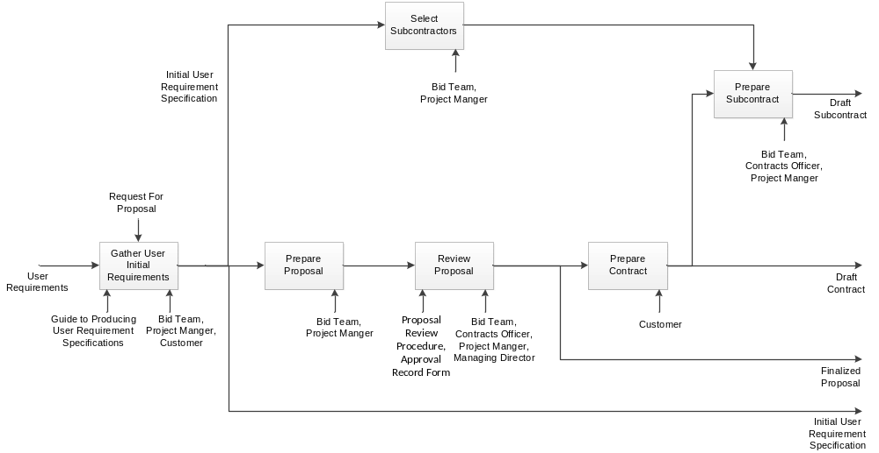

Gather Initial User Requirements

The objective of this task is
- To do a preliminary gathering of the customers’ requirements.

Input | User Requirements
Output | Initial User Requirement Specification
Entry Criteria | Received Request For Proposal from the customer.
Process Flow | Upon receiving the Request For Quotation from the customers, the Project Manager and the Bid team will contact the customers to do an initial gathering of the requirements. These requirements will then be documented as the Initial User Requirement Specifications.
Exit Criteria | Initial User Requirement Specification completed.
Resource | Project Manager  Bid team  Customers
Guidelines | Guide to Producing User Requirement Specifications (XPRESS/QMS/SQ.7)
Templates | -

Prepare Proposal

The objective of this task is
- To prepare a draft copy of the proposal.

Input | Initial User Requirement Specification
Output | Acceptance Criteria
Entry Criteria | -
Process Flow | The Project Manager and the Bid team will create a draft of a proposal based on the requirements gathered from the customers.
Exit Criteria | Draft proposal completed.
Resource | Project Manager  Bid team
Guidelines | -
Templates | -

Review Proposal

The objective of this task is
- To review and approve the draft proposal, and come out with the finalized proposal.

Input | Draft proposal
Output | Finalized proposal
Entry Criteria | -
Process Flow | The draft proposal will be submitted for review by the Contracts Officer and the Managing Director. The Project Manager and Bid Team will make any necessary changes to the proposal and finalize it.
Exit Criteria | Finalized proposal completed.
Resource | Project Manager  Bid team  Contracts Officer  Managing Director
Guidelines | Proposal Review Procedure (XPRESS/QMS/QP.5)
Templates | -

Prepare Contract

The objective of this task is
- To create the draft version of the contract.

Input | Final Proposal
Output | Draft Contract
Entry Criteria | -
Process Flow | The finalized proposal is submitted to the customers for their approval. If the customers are satisfied with the solution given in the proposal, they will create a draft copy of the contract based on the solution given in the Finalized proposal.
Exit Criteria | Draft contract completed.
Resource | Customer
Guidelines | -
Templates | -

Select Subcontractors

The objective of this task is
- To select the suitable subcontractors for the project.

Input | Initial User Requirement Specification
Output | Requirements for subcontractors
Entry Criteria | -
Process Flow | Based on the initial requirements gathered from the customers, the Project Manager and the Bid Team will select subcontractors that are suitable for the project.
Exit Criteria | Subcontractors selected for the project.
Resource | Project Manager  Bid Team
Guidelines | -
Templates | -

Prepare Subcontract

The objective of this task is
- To prepare a draft of the subcontract to be signed with the subcontractors.

Input | Requirements for subcontractors
Output | Draft contract
Entry Criteria | -
Process Flow | The Project Manager, together with the Contracts Officer and the Bid Team, will create a draft of the subcontract which will be signed by the subcontractors.
Exit Criteria | Draft contract completed.
Resource | Project Manager  Contracts Officer  Bid Team
Guidelines | -
Templates | -

Review Contract
The objective of this phase is
- To review contract prepared and signed contract, subcontract.

Input | Draft Contract  Draft Subcontract
Output | Signed Contract  Signed Subcontract
Entry Criteria | Draft Contract and Draft subcontract has been prepared.
Process Flow | Project Initiation starts after Pre-Contract is finished. All deliverables are draft.  There are seven major activities at this phase:  - Internal Review Contracts  - Customer Review Contract  - Review Subcontract  - Customer Sign Contract  - Vendor Sign Subcontract
Exit Criteria | Contract and subcontract signed.
Resource | Project Team  Managing Director  Customer
Guidelines | Control Review Checklist  Review Procedure (XPRESS/QMS/QP.7)
Templates | -

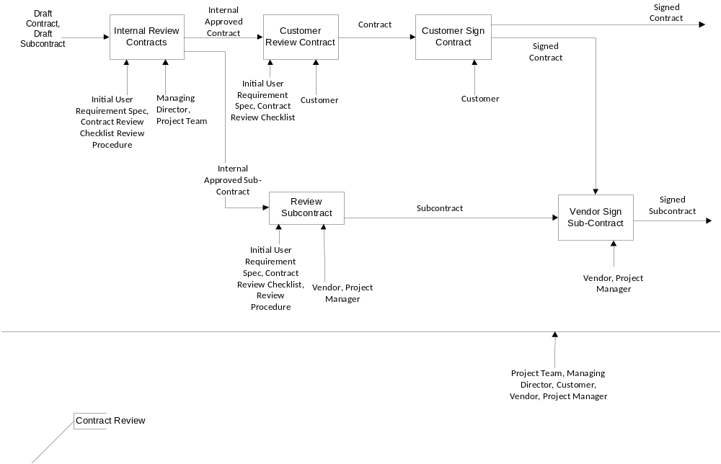

Internal Review Contracts

The objective of this task is
- To review and approve contract and subcontract.

Input | Draft Contract, Draft Subcontracts
Output | Internal Approved Contract  Internal Approved Subcontract
Entry Criteria | Draft contract and draft subcontract has been produced.
Process Flow | Draft contract and draft subcontract are reviewed and approved by managing director.
Exit Criteria | Contract has been approved internally.
Resource | Managing Director  Project Team
Guidelines | Initial User Requirement Specification  Contract Review Checklist  Review Procedure (XPRESS/QMS/QP.7)
Templates | -

Customer Review Contract

The objective of this task is
- To review draft contract.

Input | Internally Approved Contract
Output | Contract
Entry Criteria | Contract has been approved internally.
Process Flow | Customer will review the contract based on the requirement specification.
Exit Criteria | Customer has reviewed the contract.
Resource | Customer
Guidelines | Initial User Requirement Specification  Contract Review Checklist  Review Procedure (XPRESS/QMS/QP.7)
Templates | -

Review Subcontract

The objective of this task is
- To review draft subcontract.

Input | Internal Approved Subcontract
Output | Subcontract
Entry Criteria | Subcontract has been approved internally.
Process Flow | Vendor and project manager will review the subcontract based on the requirement specification.
Exit Criteria | Vendor and project manager have reviewed the subcontract.
Resource | Vendor  Project Manager
Guidelines | Initial User Requirement Specification  Contract Review Checklist  Review Procedure (XPRESS/QMS/QP.7)
Templates | -

Customer Sign Contract

The objective of this task is
- To sign contract by customer.

Input | Contract
Output | Signed Contract
Entry Criteria | Contract is reviewed by customer.
Process Flow | Customer will sign the contract.
Exit Criteria | Customer has signed the contract.
Resource | Customer
Guidelines | -
Templates | -

Vendor Sign Subcontract

The objective of this task is
- To sign subcontract by vendor and project manager.

Input | Subcontract
Output | Signed Subcontract
Entry Criteria | Subcontract has been reviewed.
Process Flow | Vendor and project manager will sign the subcontract.
Exit Criteria | Vendor and project manager have signed the subcontract.
Resource | Vendor  Project Manager
Guidelines | -
Templates | -

Project Initiation and Planning
The objective of this phase is
- To kick-off project and produce project plan, quality plan deliverables.

Input | Requirement Specifications  Project proposal  Contract
Output | Meeting Minutes, Project Plan, Quality Plan, System Filing
Entry Criteria | Customer signed the contract.
Process Flow | Project Initiation starts after Review Contracts is finished.  There are seven major activities at this phase:  - Project Kick-off  - Review Project Status  - Risk Analysis  - Risk Control  - Produce Project Plan  - Approve and Authorised Project Plan  - Product Quality Plan  - Approve and Authorised Quality Plan  - Setup Filing System
Exit Criteria | Kickoff meeting is finished, Project Plan and Quality Plan are authorized, and filing system is created.
Resource | Project Team  Managing director  Customer
Guidelines | Quality Planning (XPRESS/QMS/QP.1)  Reviews (XPRESS/QMS/QP.7)  Quality Planning Guide (XPRESS/QMS/QS.1)  Guide to Conducting Meetings (XPRESS/QMS/QS.2)  Guide to Project Filing (XPRESS/QMS/QS.3)  Project Planning Guide (XPRESS/QMS/QS.4)  Guide to using Project Initiation Forms (XPRESS/QMS/QS.5)  Technical Documentation Guide (XPRESS/QMS/QS.10)
Templates | Approval Record Form (XPRESS/QMS/QF.7)  Project Initiation Forms (XPRESS/QMS/QF.1)

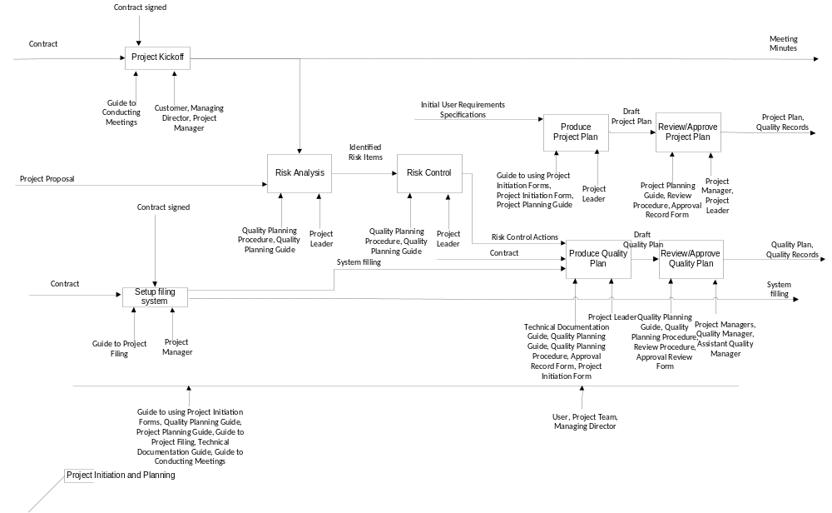

Project Kickoff

The objective of this task is
- To kick off the project.

Input | Contracts
Output | Meeting Minutes
Entry Criteria | Contract has been signed by customer
Process Flow | Project Manager will organize project kickoff meeting. Customer and managing director will attend the meeting. Meeting minutes is produce after the meeting.
Exit Criteria | Kickoff meeting completed and meeting minutes is produced.
Resource | Customer  Managing Director  Project Manager
Guidelines | Guide to Conducting Meetings
Templates | -

Produce Project Plan

The objective of this task is
- To produce project plan.

Input | Approved Requirement Specifications  Project Status Report
Output | Project Plan
Entry Criteria | Contract has been signed by customer.
Process Flow | Project manager will gather all inputs and product project plan based on Guidelines and procedure.
Exit Criteria | Draft Project Plan is produced.
Resource | Project Leader
Guidelines | Project Planning Guide (XPRESS/QMS/QS.4)  Guide to using Project Initiation Forms (XPRESS/QMS/QS.5)
Templates | Project Initiation Forms (XPRESS/QMS/QF.1)

Review/Approve Project Plan

The objective of this task is
- To approve and authorized quality plan.

Input | Draft Project Plan
Output | Project Plan
Entry Criteria | Contract has been signed by customer.
Process Flow | The Project Manager will review and authorize the project plan for project use.
Exit Criteria | Approved Project Plan is produced.
Resource | Project Leader  Project Manager
Guidelines | Review Procedure(XPRESS/QMS/QP.7)  Project Planning Guide (XPRESS/QMS/QS.4)
Templates | Approval Review Form (XPRESS/QMS/QF.7)

Risk Analysis

The objective of this task is
- To identify the risk items from project status report.

Input | Project Status Report
Output | Identified Risk Items
Entry Criteria | Contract has been signed by customer.
Process Flow | Based on input given, project leader need to produce the identified risk items which is the input to produce project plan.
Exit Criteria | Identified risk items have been produced.
Resource | Project Leader
Guidelines | Quality Planning (XPRESS/QMS/QP.1)  Quality Planning Guide (XPRESS/QMS/QS.1)
Templates | -

Risk Control

The objective of this task is
- To produce the risk control actions.

Input | Identified Risk Items
Output | Risk Control Actions
Entry Criteria | Contract has been signed by customer.
Process Flow | Based on input given, project leader need to produce the risk control actions which is the input to produce project plan.
Exit Criteria | Risk control actions have been produced.
Resource | Project Leader
Guidelines | Quality Planning (XPRESS/QMS/QP.1)  Quality Planning Guide (XPRESS/QMS/QS.1)
Templates | -

Setup Filing System

The objective of this task is
- To prepare filing system.

Input | Contract
Output | System Filing
Entry Criteria | Contract has been signed by customer.
Process Flow | Project manager will setup the filing system for project use.
Exit Criteria | Filing system has been setup.
Resource | Project Manager
Guidelines | Guide to Project Filing (XPRESS/QMS/QS.3)
Templates | -

Produce Quality Plan

The objective of this task is
- To produce the quality plan.

Input | Risk Control Actions  Contract  System Filling
Output | Quality Plan
Entry Criteria | Contract has been signed by customer.
Process Flow | Project Leader needs to produce the quality plan based on the inputs received. He needs to follow the guideline and procedure to produce the document.
Exit Criteria | Draft quality plan has been produced.
Resource | Project Leader
Guidelines | Quality Planning Procedure (XPRESS/QMS/QP.1)  Review Procedure(XPRESS/QMS/QP.7)  Quality Planning Guide (XPRESS/QMS/QS.1)  Guide to using Project Initiation Forms (XPRESS/QMS/QS.5)  Technical Documentation Guide (XPRESS/QMS/QS.10)
Templates | Project Initiation Forms (XPRESS/QMS/QF.1)  Approval Review Form (XPRESS/QMS/QF.7)

Approve and Authorized Quality Plan

The objective of this task is
- To approve and authorized quality plan.

Input | Draft Quality Plan
Output | Quality Plan, Quality Records
Entry Criteria | Contract has been signed by customer.
Process Flow | Quality Manager or Assistant Quality Manager will review the draft quality plan and approve the document. The Project Manager will authorize the quality plan for project use.
Exit Criteria | Approved Quality Plan is produced.
Resource | Quality Manager  Assistant Quality  Project Manager
Guidelines | Quality Planning Procedure (XPRESS/QMS/QP.1)  Review Procedure(XPRESS/QMS/QP.7)  Quality Planning Guide (XPRESS/QMS/QS.1)
Templates | Approval Review Form (XPRESS/QMS/QF.7)

Requirements Control
The objective of this phase is
- To prepare the customer requirement documents and sign off the requirement spec by the customer.

Input | Initial Requirements  Project Initiation Form
Output | Requirement Specification  Review Records
Entry Criteria | Project Initiation and Planning is completed.
Process Flow | This phase starts when the project initiation and planning is completed.
Exit Criteria | Customer reviewed and approved the requirement specification.
Resources | Project Manager  Project Leaders  Customer
Guidelines | Guide to Producing User Requirement Specification(XPRESS/QMS/QS.7)  Review Procedure(XPRESS/QMS/QP.7)
Templates | Approval record form(XPRESS/QMs/QF.7)

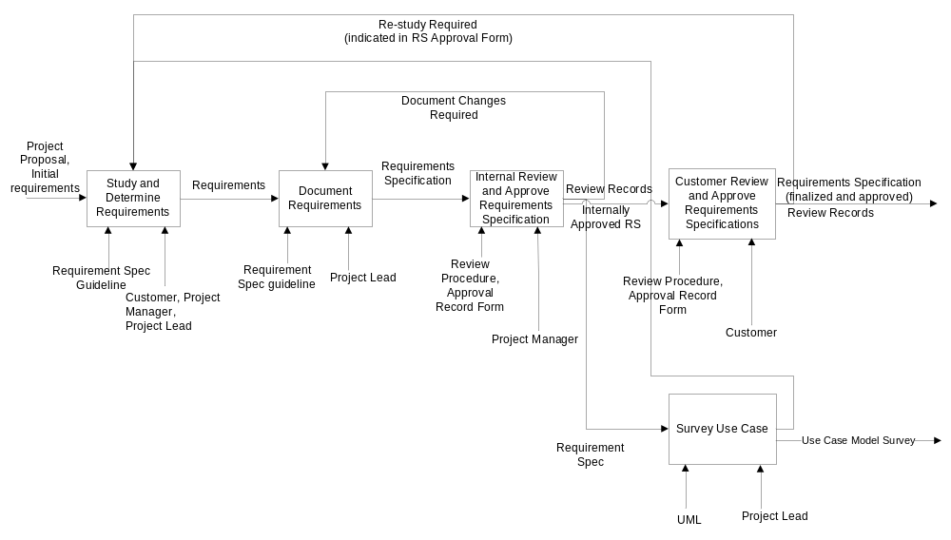

Study and Determine Requirements

The objective of this task is
- To do a requirement gathering meeting with customer and come out with the list of requirements.

Input | Project Plan
Output | List of requirements
Entry Criteria | Project Initiation and Planning is completed
Process Flow | Once the project initiation and planning is done, Project Manager, Project Leader and the customer conduct interview sessions to determine the list of requirements.
Exit Criteria | The list of requirements is determined.
Resources | Project Manager  Project Leaders  Customer
Guideline | Guide to Producing User Requirement Specification(XPRESS/QMS/QS.7)
Templates | -

Document Requirements

The objective of this task is
- To create requirement document based on the list of requirements.

Input | List of requirements
Output | Requirement specification
Entry Criteria | The list of requirements is determined.
Process Flow | Based on the requirement list from the study and determine the requirements, project leader will create the requirement specification.
Exit Criteria | Requirement specification document is created.
Resources | Project Leaders
Guideline | Guide to Producing User Requirement Specification(XPRESS/QMS/QS.7)
Template | -

Internal Review and Approve Requirement Specification

The objective of this task is
- To perform internal review of the requirement document and ensure not to miss any functionality given by the customer during the requirement gathering meeting.

Input | Requirement Specification
Output | Internally approved requirement specification
Start Criteria | Requirement specification is documented.
Process Flow | Project manager will review requirement specification and create review records if any changes required. Project manager will approve after all the changes required are done
Exit Criteria | Requirement specification document is approved internally.
Resources | Project Manager
Guidelines | Review Procedure(XPRESS/QMS/QP.7)
Templates | Approval record form(XPRESS/QMs/QF.7)

Customer Review and Approve Requirement Specification

The objective of this task is
- To review the requirement document and ensure not to miss any functionality given by the user during the requirement gathering meeting.

Input | Internally approved Requirement Specification
Output | Approved & finalized requirement specification
Start Criteria | Requirement specification is approved internally.
Process Flow | Customer Review and approve requirement specification  The customer will review requirement specification and create review records if any changes or re-study of requirement is required. Customer will approve after all the changes required are done
Exit Criteria | Requirement specification document is approved by the customer.
Resources | Customer
Guidelines | Review Procedure(XPRESS/QMS/QP.7)
Templates | Approval record form(XPRESS/QMs/QF.7)

Survey Use Case

The objective of this task is
- To review the requirement document and ensure not to miss any functionality given by the user during the requirement gathering meeting.

Input | Internally approved Requirement Specification
Output | Use Case Model Survey
Start Criteria | Requirement specification is approved internally.
Process Flow | Project Lead will perform surveying of the use case and create Use Case Model Survey. If any changes needs in requirement specification and need clarification with the customer then it will go back to study requirements task.
Exit Criteria | Use case model survey is created.
Resources | Customer
Guidelines | UML
Templates | -

Design Control

The objective of this phase is
- To transform the requirements into a design of the system
- To evolve a robust architecture for the system
- To adapt the design to match the implementation environment.

Input | Requirement Specifications
Output | Design Specification
Entry Criteria | Requirement Specification is authorized.
Process Flow | Design Control starts when the Requirements Specification is completed and accepted by the customers.  There are three major activities at this phase:  - Prepare development environment and train development team, to identify development environment and purchase necessary hardware / software as needed, and to perform necessary training for development team.  - Analysis modelling, to transform the Requirement Specification and Use Case Model Survey into an implementation-independent Use Case Realization Report.  - Design modelling, to transform the UCRR (Analysis) into the design model specific to the selected implementation environment.
Exit Criteria | Design Specification is authorized.
Resource | Development team  Project manager  Project leader
Guidelines | Technical Documentation Guide (XPRESS/QMS/QS.10)  Guide to Writing Style (XPRESS/QMS/QS.11)  Guide to Conduct Design Reviews (XPRESS/QMS/QS.19)  Change Request and Approval (XPRESS/QMS/QP.8)
Templates | Approval Record Form (XPRESS/QMS/QF.7)  Change Request Form (XPRESS/QMS/QF.3)  Action List Form (XPRESS/QMS/QF.8)

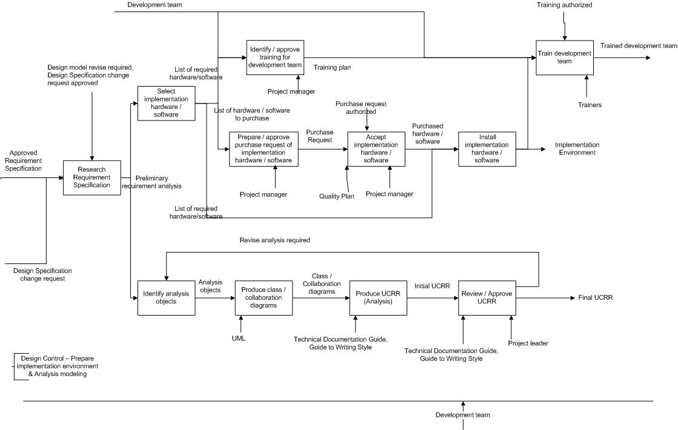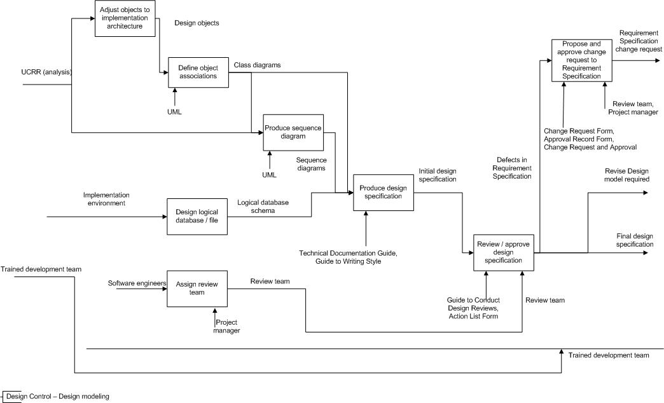
Tasks 4.6.1 ~ 4.6.6 is to prepare the implementation environment.

Research Requirement Specification

The objective of this task is
- To identify technical alternatives.
- To identify functional sub-systems when applicable.

Input | Requirement Specifications
Output | Preliminary requirement analysis
Entry Criteria | -
Process Flow | The development team will perform preliminary study on the Requirement Specification, and determine technical alternatives and functional sub-systems (when applicable).
Exit Criteria | -
Resource | Development team
Guidelines | -
Templates | -

Select development hardware / software

The objective of this task is
- To determine the proper hardware and software for implementation.

Input | Preliminary requirement analysis
Output | List of required hardware / software
Entry Criteria | -
Process Flow | The development team will identify the required hardware / software to implement the requirement, and also examine the hardware / software currently available for development, to determine if they are sufficient for the project.  If there is gap between existing resources and required, the team will prepare the list of hardware / software to fill the gap, and process to Identify / approve purchase of development hardware / software.  If existing resources are sufficient, proceed to Install development hardware / software.
Exit Criteria | -
Resource | Development team
Guidelines | -
Templates | -

Identify / approve purchase of development hardware / software

The objective of this task is
- To get the approval from Project manager on the hardware / software to be purchased for the project.

Input | List of required hardware / software
Output | Purchase request of hardware / software
Entry Criteria | -
Process Flow | The development team will prepare the purchase request of the hardware / software to be purchased, and submit to Project Manager for approval.
Exit Criteria | -
Resource | Development team  Project manager
Guidelines | Guideline for Using Purchase Request Forms (XPRESS/QMS/QS.16)  Refer to Section 5.4.2 / Para 1
Templates | Purchase Request Form (XPRESS/QMS/QF.4)

Accept development hardware / software

The objective of this task is
- To accept the purchased hardware / software according to the quality standard.

Input | Purchase Request
Output | Purchased hardware / software
Entry Criteria | The purchase request is authorized by Administration Manager.
Process Flow | The Project Manager will ensure purchased hardware / software meets all acceptance criteria specified in the Quality Plan. (Refer to section 5.4.2)
Exit Criteria | -
Resource | Project manager
Guidelines | Quality Planning Procedure (XPRESS/QMS/QP.1)
Templates | -

Install development hardware / software

The objective of this task is
- To install all required hardware / software, and get the development environment ready.

Input | List of required hardware / software  Purchased hardware / software
Output | Implementation environment
Entry Criteria | -
Process Flow | The development team will install all the hardware / software.
Exit Criteria | -
Resource | Development
Guidelines | -
Templates | -

Identify / approve training for development team

The objective of this task is
- To identify and approve the training needs of the development team for the project specific hardware / software.

Input | List of required hardware / software
Output | Training plan
Entry Criteria | -
Process Flow | The Personnel Officer will assess the skills of development team, and identify any shortage against the project hardware / software.  In case of any gap identified, he’ll prepare the training plan and get the approval from the Project Manager. (Refer to Section 5.5)
Exit Criteria | The training plan is approved by Project Manager
Resource | Project manager  Personnel Officer
Guidelines | -
Templates | -

Train development team

The objective of this task is
- To ensure the development team possess sufficient skills for the implementation.

Input | Training plan,  Implementation environment  Development team
Output | Trained development team
Entry Criteria | Training plan is authorized by Administration Manager.
Process Flow | The trainers will perform training to the development team.
Exit Criteria | Training effect is evaluated and training records are kept. (Refer to Section 5.5)
Resource | Internal / external trainers  Personnel Officer
Guidelines | -
Templates | -

Tasks 4.6.7 ~ 4.6.10 is to produce the Use Case Realization Report (analysis).

Identify analysis objects

The objective of this task is
- To identify analysis objects for each use case.

Input | Preliminary requirement analysis
Output | Analysis objects
Entry Criteria | -
Process Flow | The development team will identify the analysis objects for each use case.
Exit Criteria | -
Resource | Development team
Guidelines | -
Templates | -

Produce class / collaboration diagrams

The objective of this task is
- To draft the class diagrams and collaboration diagrams for each use case.

Input | Analysis objects
Output | Class / collaboration diagrams
Entry Criteria | -
Process Flow | The development team will draw the class diagrams and collaboration diagrams for each use case.
Exit Criteria | -
Resource | Development team
Guidelines | UML
Templates | -

Produce Use Case Realization Report (UCRR)

The objective of this task is
- To consolidate diagrams of all use cases and produce the initial UCRR (analysis).

Input | Class / collaboration diagrams for each use case
Output | Initial UCRR
Entry Criteria | -
Process Flow | The Development team will produce the initial Use Case Realization Report (Analysis).
Exit Criteria | -
Resource | Development team
Guidelines | Technical Documentation Guide (XPRESS/QMS/QS.10)  Guide to Writing Style (XPRESS/QMS/QS.11)
Templates | -

Review / approve UCRR

The objective of this task is
- To finalize the UCRR (analysis).

Input | Initial UCRR
Output | Final UCRR
Entry Criteria | -
Process Flow | The development team will review the UCRR (analysis) with the Project Leader.  If defects are found, the team will propose revise requests, or else, the Project leader will approve the UCRR.
Exit Criteria | The UCRR is approved.
Resource | Development team  Project leader
Guidelines | Technical Documentation Guide (XPRESS/QMS/QS.10)  Guide to Writing Style (XPRESS/QMS/QS.11)
Templates | -

Tasks 4.6.12 ~ 4.6.17 is to produce the Design Model.

Adjust objects to implementation architecture

The objective of this task is
- To transform analysis object into design objects specific to the implementation.

Input | UCRR (analysis)
Output | Design object
Entry Criteria | -
Process Flow | The development team will analyse will analyse the analysis model, and define the design objects for the analysis objects. The attributes and operations of each object will also be identified.
Exit Criteria | -
Resource | Development team
Guidelines | -
Templates | -

Define object associations

The objective of this task is
- To structure the design objects for implementation.

Input | Design objects
Output | Design class diagrams
Entry Criteria | -
Process Flow | The development team will determine the association between design objects and get the structure of design objects.
Exit Criteria | -
Resource | Development team
Guidelines | UML
Templates | -

Produce sequence diagrams

The objective of this task is
- To transform analysis collaboration diagrams of each use case into design sequence diagrams.

Input | UCRR (analysis)  Class diagrams
Output | Design sequence diagrams
Entry Criteria | -
Process Flow | The development team will draw the sequence diagram for each use case based on the analysis collaboration diagram.
Exit Criteria | -
Resource | Development team
Guidelines | UML
Templates | -

Produce initial Design Specification

The objective of this task is
- To compile the design objects and diagrams into a design specification

Input | Class diagrams  Sequence diagrams
Output | Initial Design Specification
Entry Criteria | -
Process Flow | The Development team will compile all class diagrams and sequence diagrams, and produce the initial Design Specification.
Exit Criteria | -
Resource | Development team  Project Leader
Guidelines | Technical Documentation Guide (XPRESS/QMS/QS.10)  Guide to Writing Style (XPRESS/QMS/QS.11)
Templates | -

Assign design review team

The objective of this task is
- To form the design review team.

Input | Software Engineers
Output | Review team
Entry Criteria | -
Process Flow | This task can be in parallel with other design tasks, and completed before initial Design Specification is ready.
Exit Criteria | -
Resource | Project Manager
Guidelines | -
Templates | -

Review / approve Design Specification

The objective of this task is
- To finalize the Design Specification.

Input | Initial Design Specification
Output | Final Design Specification  Revise design model required  Defects in Requirement Specification
Entry Criteria | -
Process Flow | The Design Review Team will review the Design Specification.  If defects are found, the review team will analyse the defects, and propose revise requests to the design model, and trigger Research Requirement Specification.  Any defects which root cause is in Requirement Specification will lead to Propose / approve change request to Requirement Specification.  If no defect, the Project Leader will approve the Design Specification.
Exit Criteria | The approval is recorded. (Refer to section 5.3.3)  The Design Specification is properly controlled.(Refer to section 5.3.2)
Resource | Design Review team  Project Leader
Guidelines | Technical Documentation Guide (XPRESS/QMS/QS.10)  Guide to Writing Style (XPRESS/QMS/QS.11)
Templates | Approval Record Form (XPRESS/QMS/QF.7)

Propose / approve change request to Requirement Specification

The objective of this task is
- To get approval for the change request to Requirement Specification.

Input | Defects in Requirement Specification
Output | Change request to Requirement Specification
Entry Criteria | -
Process Flow | The review team will prepare the change request for the defects in Requirement Specification, and submit it to Project Manager for approval.
Exit Criteria | The approval of change request to Requirement Specification is recorded. (Refer to section 5.3.4)
Resource | Design Review team
Guidelines | Change Request and Approval (XPRESS/QMS/QP.8)
Templates | Approval Record Form (XPRESS/QMS/QF.7)  Change Request Form (XPRESS/QMS/DF.3)

Programming and User Documentation Control
The objective of this task is:
- Develop the source code based on the design.
- Performing unit test to ensure the software quality.
- Update user document to meet with the coding.

Input | Design Spec, Initial Operation Manual, Initial User Manual
Output | Integrated System, Updated Operation Manual, Updated User Manual.
Entry Criteria | Design Spec Approved
Process Flow | Programming and user documentation control starts after design control is finished.  There are three major activities at this phase:  - Develop the source code based on the design.  - Performing unit test to ensure the software quality.  - Update user document to meet with the coding.
Exit Criteria | System is integrated and operation & user manual are updated.
Resources | Project Leaders  Software Engineers
Guidelines | Technical Documentation Guide (XPRESS/QMS/QS.10)  C Programming Guideline (XPRESS/QMS/QS.8)  C++ Programming Guideline (XPRESS/QMS/QS.9)  Guide to Code Walkthroughs (XPRESS/QMS/QS.12)
Templates | Approval Record Form (XPRESS/QMS/QF.7)  Change Request Form (XPRESS/QMS/QF.3)  Review procedure (XPRESS/QMS/QP.7)

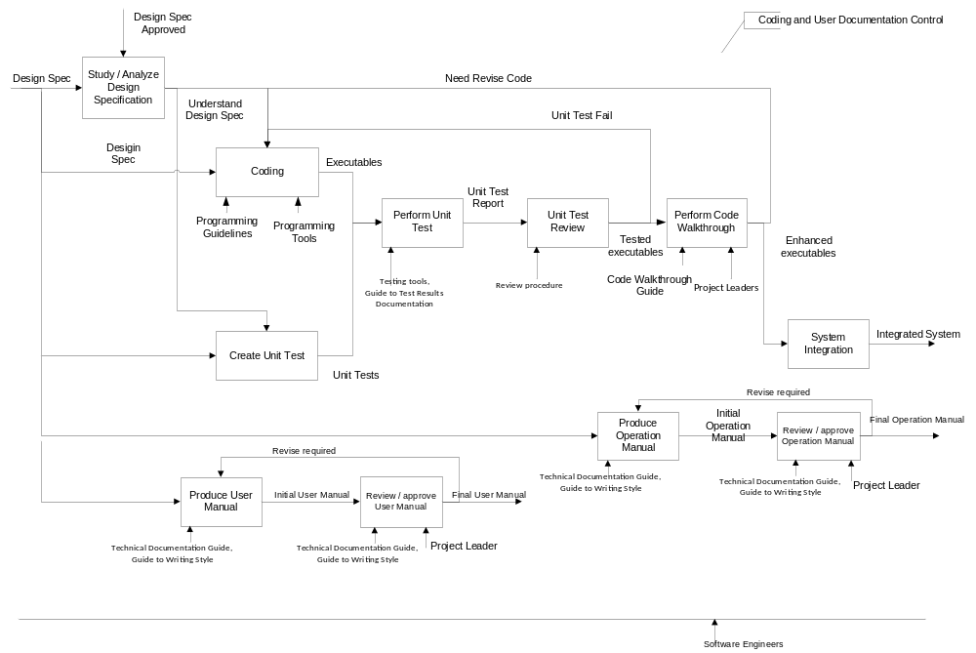

Study / Analyze Design Specification

The objective of this task is
- To allow the developers to study and understand the Design Specification.

Input | Design Spec
Output | -
Entry Criteria | Design Specification approved.
Process Flow | The developers read the design spec and understand what and how to start coding.
Exit Criteria | Fully understand the design spec and can start coding.
Resources | Software Engineers  Project Leaders
Guidelines | -
Templates | -

Coding

The objective of this task is
- To create the codes for the system.

Input | Design Spec
Output | Executable files (Components)
Entry Criteria | Understand the design spec, or unit test fail or need to revise code.
Process Flow | The developers start coding based on the design spec.
Exit Criteria | The code can be compiled and made into an executable file.
Resources | Software Engineers  Project Leaders
Guidelines | C Programming Guideline (XPRESS/QMS/QS.8),  C++ Programming Guideline (XPRESS/QMS/QS.9)
Templates | -

Create Unit Test

The objective of this task is
- To create the unit tests.

Input | Design Spec
Output | Unit tests
Entry Criteria | -
Process Flow | The developers create the unit tests based on the design specification.
Exit Criteria | Unit tests complete successful.
Resources | Software Engineers
Guidelines | Testing tools
Templates | -

Perform Unit Test

The objective of this task is
- To run the units tests.

Input | Unit test cases, Executable files
Output | Unit tests
Entry Criteria | -
Process Flow | The developers execute the unit tests to generate unit test report.
Exit Criteria | Unit tests reports are generated.
Resources | Software Engineers  Testing tools
Guidelines | Guide to Test Results Documentation (XPRESS/QMS/QS.18)
Templates | -

Unit Test Review

The objective of this task is
- To review the results of the unit tests.

Input | Unit tests report
Output | -
Entry Criteria | Unit tests report are generated
Process Flow | The developers follow the Reviews procedure (XPRESS/QMS/QP.7) to review the test result, if unit test failed, go back to coding again, otherwise go to the next step.
Exit Criteria | Unit tests passed.
Resources | Software Engineers  Project Leaders
Guidelines | Review procedure (XPRESS/QMS/QP.7)
Templates | -

Perform Code Walkthrough

The objective of this task is
- To perform code walkthrough for the codes produced.

Input | Selected source codes
Output | -
Entry Criteria | Unit Tests are passed.
Process Flow | The Developers perform the code walkthrough, if code need revise, go back to coding, if need change request, fill the change request form; otherwise go to the next step.
Exit Criteria | Code walkthrough completed.
Resources | Project Leaders
Guidelines | Guide to Code Walkthroughs (XPRESS/QMS/QS.12)
Templates | -

Produce Operation Manual

The objective of this task is
- To produce the operation manual.

Input | Design Specification
Output | Initial operations manual
Entry Criteria | -
Process Flow | The Developers produce the operation manual based on the current coding.
Exit Criteria | Operations manual produced.
Resources | Software Engineers  Project Leaders
Guidelines | Technical Documentation Guide (XPRESS/QMS/QS.10)  Guide to Writing Style (XPRESS/QMS/QS.11)
Templates | -

Review / approve Operation Manual

The objective of this task is
- To review and approve the operation manual.

Input | Initial operation manual
Output | Final operation manual
Entry Criteria | -
Process Flow | The Developers review the operation manual, and get approval from the Project leader.  If any issue is found, the Produce User Manual will be triggered.
Exit Criteria | Operations manual updated.
Resources | Software Engineers  Project Leaders
Guidelines | Technical Documentation Guide (XPRESS/QMS/QS.10)  Guide to Writing Style (XPRESS/QMS/QS.11)
Templates | -

Produce User Manual

The objective of this task is
- To produce the user manual.

Input | Design Specification
Output | Initial user manual
Entry Criteria | -
Process Flow | The Developers produce the user manual based on the current coding.
Exit Criteria | User manual produced.
Resources | Software Engineers  Project Leaders
Guidelines | Technical Documentation Guide (XPRESS/QMS/QS.10)  Guide to Writing Style (XPRESS/QMS/QS.11)
Templates | -

Review / approve User Manual

The objective of this task is
- To review and approve the user manual.

Input | Initial user manual
Output | Final user manual
Entry Criteria | -
Process Flow | The Developers review the user manual based on the current coding, and get approval from the Project leader.  If any issue is found, the Produce User Manual will be triggered.
Exit Criteria | User manual is completed.
Resources | Software Engineers  Project Leaders
Guidelines | Technical Documentation Guide (XPRESS/QMS/QS.10)  Guide to Writing Style (XPRESS/QMS/QS.11)
Templates | -

System Integration

The objective of this task is
- To integrate the components of the system.

Input | Executable files (Components)
Output | Integrated System
Entry Criteria | -
Process Flow | The Developers perform integrate the components to a complete system.
Exit Criteria | Integration is completed.
Resources | Software Engineers  Project Leaders
Guidelines | -
Templates | -

Testing and Validation
The objective of this phase is
- To validate the system before passing it to the acceptance test by the customer.

Input | Integrated System, Requirement Spec, Operation Manual, User Manual
Output | Tested System, Updated Operations Manual, Updated User Manual
Entry Criteria | Programming & user documentation control is completed and the system is already integrated.
Process Flow | The integrated system will be tested based on the test plan that cover all the requirement scope and test result will be reviewed and proceed to the acceptance test phase once all the test result are passed.
Exit Criteria | Once the system integration test is passed and Operations and User Manual are updated.
Resources | Software Engineer
Guidelines | Guide to Test Planning(XPRESS/QMS/QS.14)  Review Procedure(XPRESS/QMS/QP.7)  Guide to test result documentation(XPRESS/QMS/QS.17)  Technical Documentation guide line(XPRESS/QMS/QS.10)
Templates

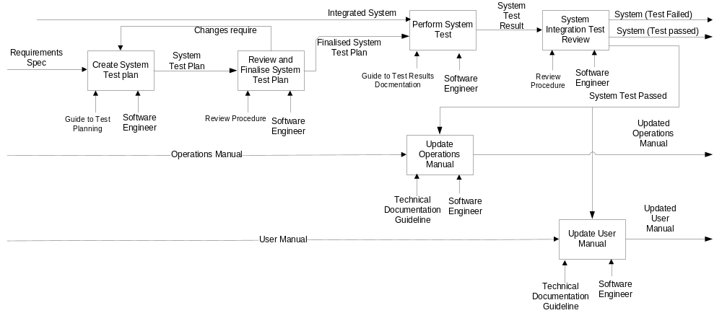

Create System Test Plan

The objective of this task is
- To create a comprehensive system test plan for the test team to follow.

Input | Integrated System, Requirement Spec, Operation Manual, User Manual
Output | Tested System, Updated Operations Manual, Updated User Manual
Entry Criteria | Programming & user documentation control is completed and the system is already integrated.
Process Flow | Software Engineer creates system test plan by referring to the signed off requirement specification.
Exit Criteria | Once the system integration test is passed and Operations and User Manual are updated.
Resources | Software Engineer
Guidelines | Guide to Test Planning(XPRESS/QMS/QS.14)
Templates

Review and Finalize System Test Plan

The objective of this task is
- To review the system test plan and ensure test plan cover all the scope.

Input | Integrated System, Requirement Spec, Operation Manual, User Manual
Output | Tested System, Updated Operations Manual, Updated User Manual
Entry Criteria | Programming & user documentation control is completed and the system is already integrated.
Process Flow | Software Engineer will review the system test plan and send the review records to creator of the system test plan if any changes require. Once the system test plan is completed and finalized, send the system test plan to the system testing team.
Exit Criteria | Once the system integration test is passed and Operations and User Manual are updated.
Resources | Software Engineer
Guidelines | Review Procedure(XPRESS/QMS/QP.7)
Templates

Perform System Test

The objective of this task is
- To test the system based on the test plan

Input | Integrated System, Requirement Spec, Operation Manual, User Manual
Output | Tested System, Updated Operations Manual, Updated User Manual
Entry Criteria | Programming & user documentation control is completed and the system is already integrated.
Process Flow | Perform the system test by following system test plan and create the test result.
Exit Criteria | Once the system integration test is passed and Operations and User Manual are updated.
Resources | Software Engineer
Guidelines | Guide to test result documentation(XPRESS/QMS/QS.17)
Templates

System Integration Test Review

The objective of this task is
- To review the test result and determine what to do next.

Input | Integrated System, Requirement Spec, Operation Manual, User Manual
Output | Tested System, Updated Operations Manual, Updated User Manual
Entry Criteria | Programming & user documentation control is completed and the system is already integrated.
Process Flow | Review the test result and send the test result to the development team if the test results failed. After test result is clear and passed, proceed to Acceptance Test phase.
Exit Criteria | Once the system integration test is passed and Operations and User Manual are updated.
Resources | Software Engineer
Guidelines | Review Procedure(XPRESS/QMS/QP.7)
Templates

Update Operation Manual

The objective of this task is
- To have an updated operation manual as the latest change done to the system

Input | Integrated System, Requirement Spec, Operation Manual, User Manual
Output | Tested System, Updated Operations Manual, Updated User Manual
Entry Criteria | Programming & user documentation control is completed and the system is already integrated.
Process Flow | Update operation manual based on the any changes done after the system test.
Exit Criteria | Once the system integration test is passed and Operations and User Manual are updated.
Resources | Software Engineer
Guidelines | Technical Documentation guide line(XPRESS/QMS/QS.10)
Templates

Update User Manual
The objective of this task is
- To have a updated user manual as the latest change done to the system

Input | Integrated System, Requirement Spec, Operation Manual, User Manual
Output | Tested System, Updated Operations Manual, Updated User Manual
Entry Criteria | Programming & user documentation control is completed and the system is already integrated.
Process Flow | Update user manual based on the any changes done after the system test.
Exit Criteria | Once the system integration test is passed and Operations and User Manual are updated.
Resources | Software Engineer
Guidelines | Technical Documentation guide line(XPRESS/QMS/QS.10)
Templates

Acceptance

The objective of this phase is
- To obtain customer’s acceptance that the product meets the requirements.

Input | Requirement Specifications  Development team
Output | Customers sign off
Entry Criteria | Requirement Specification is accepted by customer.
Process Flow | Planning of Acceptance Test may start after Requirement Specification is finished, though the execution could only take off after Test and Validation is completed.  There are three major activities at this phase:  - Prepare the UAT plan  - Perform UAT test  - Get customer’s sign-off
Exit Criteria | The customer sign-off and accept the product.
Resource | Test team  Customer  Project Manger
Guidelines | Technical Documentation Guide (XPRESS/QMS/QS.10)  Guide to Writing Style (XPRESS/QMS/QS.11)  Corrective Action (section 3.6.3)  Change Request and Approval (XPRESS/QMS/QP.8)
Templates | Approval Record Form (XPRESS/QMS/QF.7)  Change Request Form (XPRESS/QMS/QF.3)

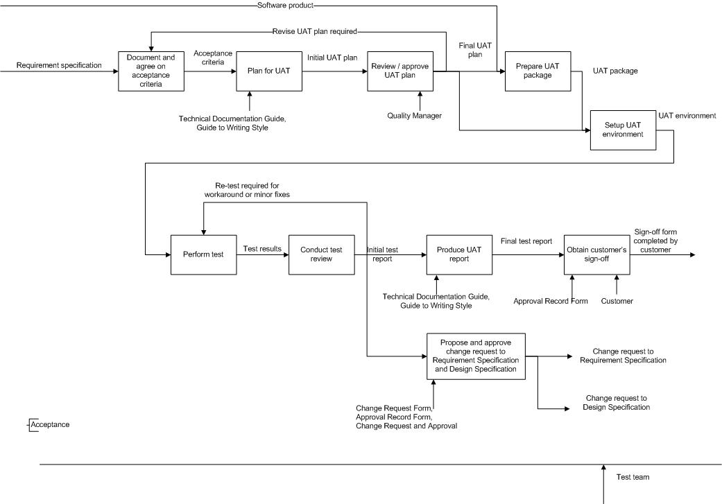

Document and agree on acceptance criteria

The objective of this task is
- To identify the acceptance criteria from Requirement Specification.

Input | Requirement Specification
Output | Acceptance Criteria
Entry Criteria | The Test team is formed.
Process Flow | This task starts after the Test team is formed.  This task might be triggered again when revising UAT plan is required.
Exit Criteria | -
Resources | Test team  Customer
Guidelines / Tools | -
Templates | -

Prepare UAT plan

The objective of this task is
- To produce the initial UAT plan.

Input | Acceptance criteria
Output | Initial UAT plan
Entry Criteria | -
Process Flow | The Test team will compile all acceptance criteria identified into initial UAT plan.
Exit Criteria | -
Resources | Project Leader
Guidelines | Technical Documentation Guide (XPRESS/QMS/QS.10)  Guide to Writing Style (XPRESS/QMS/QS.11)
Templates | -

Review / approve UAT plan

The objective of this task is
- To finalize the UAT plan.

Input | Initial UAT plan
Output | Final UAT plan
Entry Criteria | -
Process Flow | The Test team and Quality manager will review the UAT plan against the Requirement Specification and other reference documents.  In case of any issues identified, they’ll propose revise request, thus trigger Document and agree on acceptance criteria.  If no issue is found, the Quality manager will approve the UAT plan.
Exit Criteria | The approval is recorded. (Refer to section 5.3.3)  The UAT plan is properly controlled.(Refer to section 5.3.2)
Resources | Quality manager  Test team
Guidelines | Technical Documentation Guide (XPRESS/QMS/QS.10)  Guide to Writing Style (XPRESS/QMS/QS.11)
Templates | Approval Record Form (XPRESS/QMS/QF.7)

Prepare UAT package

The objective of this task is
- To prepare the software package for UAT.

Input | Final UAT Plan  Tested product
Output | UAT package
Entry Criteria | -
Process Flow | This task starts after the software product is tested and validated.  The Test team will prepare a package containing the product and related user documents.
Exit Criteria | -
Resources | Test team
Guidelines | Technical Documentation Guide (XPRESS/QMS/QS.10)  Guide to Writing Style (XPRESS/QMS/QS.11)
Templates | -

Setup UAT environment

The objective of this task is
- To get the UAT environment ready.

Input | Final UAT plan  UAT package
Output | UAT environment
Entry Criteria | -
Process Flow | The Test team will  - Install a system with required hardware and software.  - Deploy the UAT package to the above system.  - Get additional testing tools or devices ready.
Exit Criteria | -
Resources | Test team
Guidelines | -
Templates | -

Perform test

The objective of this task is
- To collect the test results of each test case and scenarios.

Input | UAT environment
Output | Test results
Entry Criteria | -
Process Flow | The Test team will execute the test cases and scenarios together with customer, and record down the test results.  This task may be triggered again when workaround or minor fix is applied.
Exit Criteria | -
Resources | Test team  Customer
Guidelines | -
Templates | -

Conduct test review

The objective of this task is
- To ensure test cases and scenarios are executed.

Input | Test results
Output | Initial test report  Re-test required for workaround or minor fixes
Entry Criteria | -
Process Flow | The Test team with review the test results, and produce the initial UAT report.  In case of minor issues, the team will come out and apply workaround or quick fixes, and re-test the related use cases.
Exit Criteria | All test cases and scenarios are covered.
Resources | Test team
Guidelines | Technical Documentation Guide (XPRESS/QMS/QS.10)  Guide to Writing Style (XPRESS/QMS/QS.11)
Templates | -

Produce UAT report

The objective of this task is
- To ensure all acceptance criteria are met.

Input | Initial test report
Output | Final UAT Report
Entry Criteria | -
Process Flow | This task will produce the final UAT report, and decide if the product is at an acceptable status.  If yes, proceed to Obtain user’s sign-off; or else, the team need analyse / record the root cause of the issues affecting the acceptance.  If the root cause is in the Requirement Specification or Design Specification, proceed to Propose / approve change request to Requirement Specification or Design Specification
Exit Criteria | All acceptance criteria are met.
Resources | Test team  Customer
Guidelines | Technical Documentation Guide (XPRESS/QMS/QS.10)  Guide to Writing Style (XPRESS/QMS/QS.11)
Templates | -

Obtain user’s sign off

The objective of this task is
- To obtain user’s sign-off on the acceptance.

Input | UAT report
Output | Acceptance form with user’s sign-off.
Entry Criteria | -
Process Flow | -
Exit Criteria | Record of sign off is kept.
Resources | Customer
Guidelines | -
Templates | Approval Record Form (XPRESS/QMS/QF.7)

Propose / approve change request to Requirement Specification or Design Specification

The objective of this task is
- To get approval on change request to Requirement Specification or Design Specification.

Input | UAT report
Output | Change Request to Requirement Specification or Design Specification
Entry Criteria | -
Process Flow | The Test team will raise change requests for those defects which root cause is in Requirement Specification or Design Specification, and get the approval on the above change requests.
Exit Criteria | Approval of Change Request is recorded and kept. (Refer to section 5.3.4)
Resources | Test team  Project manager
Guidelines | Change Request and Approval (XPRESS/QMS/QP.8)
Templates | Approval Record Form (XPRESS/QMS/QF.7)  Change Request Form (XPRESS/QMS/DF.3)

Delivery and Installation
The objective of this task is:
- Delivery the hardware / software to the customer
- Install the new system
- Update and finalize the user manual and operation manual

Input | Updated Installation Plan, Updated User Manual, Updated Operation Manual
Output | Production System, Finial User Manual, Final Operation Manual
Entry Criteria | UAT Approved
Process Flow | Delivery and installation starts after acceptance is finished.  There are three major activities at this phase:  - Delivery the hardware / software to the customer.  - Install the new system.  - Update and finalize the user manual and operation manual.
Exit Criteria | The customer sign-off for the new system and user manual are finalized.
Resources | Project Manager  Project Leaders  Software Engineers  Customers
Guidelines | Technical Documentation Guide (XPRESS/QMS/QS.10)
Templates | Review procedure (XPRESS/QMS/QP.7),  Approval Record Form (XPRESS/QMS/QF.7)

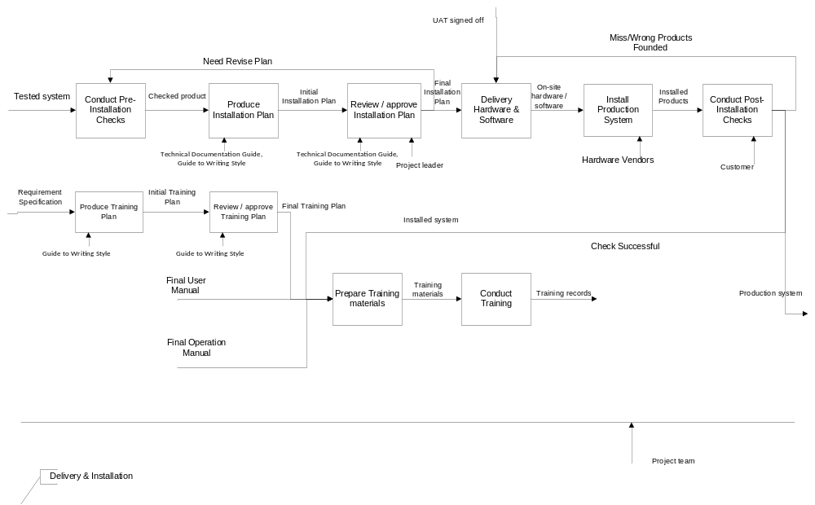

Conduct Pre-Installation Checks

The objective of this task is
- To do a preliminary check before installation.

Input | Tested system
Output | Checked product.
Entry Criteria | -
Process Flow | The project team and customer check the details before installation, if some problem founded, then need revise the installation plan, otherwise go to the next step.
Exit Criteria | Check is finished.
Resources | Project Manager  Project Leader  Customer
Guidelines | -
Templates

Produce Installation Plan

The objective of this task is
- To produce the installation plan.

Input | Checked product
Output | Initial Installation Plan
Entry Criteria | UAT Approved or the plan needs to be revised.
Process Flow | The project team and customer review the installation plan.
Exit Criteria | Installation plan is reviewed.
Resources | Project Manager  Project Leader  Customer
Guidelines | Technical Documentation Guide (XPRESS/QMS/QS.10)  Guide to Writing Style (XPRESS/QMS/QS.11)
Templates | -

Review / approve Installation Plan

The objective of this task is
- To review and approve the installation plan.

Input | Initial Installation Plan
Output | Final Installation Plan
Entry Criteria | UAT Approved or the plan needs to be revised.
Process Flow | The project team and customer review the installation plan.
Exit Criteria | Installation plan is reviewed.
Resources | Project Manager  Project Leader  Customer
Guidelines | Technical Documentation Guide (XPRESS/QMS/QS.10)  Guide to Writing Style (XPRESS/QMS/QS.11)
Templates | Review procedure (XPRESS/QMS/QP.7),  Approval Record Form (XPRESS/QMS/QF.7)

Delivery Hardware & Software

The objective of this task is
- To deliver the hardware and software for the system.

Input | Installation plan
Output | On-site hardware / software
Entry Criteria | Pre-installation is done.
Process Flow | The Hardware & Software for the new system are delivered to the customer’s place.
Exit Criteria | Delivery complete successful.
Resources | Project team
Guidelines | -
Templates | -

Install Production System

The objective of this task is
- To install the production system.

Input | On-site hardware / software
Output | Installed system
Entry Criteria | Delivery is done
Process Flow | The Hardware vendor installs the hardware and project team to install the software.
Exit Criteria | Installation complete successful.
Resources | Hardware Vendor  Project Leader  Software Engineers
Guidelines | -
Templates | Approval Record Form (XPRESS/QMS/QF.7)

Conduct Post-Installation Checks

The objective of this task is
- To do a check on the system after it is installed.

Input | Installed system
Output | Production system
Entry Criteria | Installation is done
Process Flow | The project team and customer check the details for the installation. If the installation is successfully installed without any errors, go to the next step. Otherwise the installation must be redone.
Exit Criteria | Checks successfully completed.
Resources | Customer  Project Leader  Software Engineer
Guidelines | Review procedure (XPRESS/QMS/QP.7)
Templates | Approval Record Form (XPRESS/QMS/QF.7)

Produce Training Plan

The objective of this task is
- To produce the training plan.

Input | Requirement Specification
Output | Initial Training Plan
Entry Criteria | User manual and operation manual are reviewed and the system is installed complete successful.
Process Flow | The software engineers will prepare a plan for the training.
Exit Criteria | -
Resources | Software Engineers  Project Leader
Guidelines | Guide to Writing Style (XPRESS/QMS/QS.11)
Templates | -

Review / approve Training Plan

The objective of this task is
- To review and approve the training plan.

Input | Initial Training Plan
Output | Final Training Plan
Entry Criteria | User manual and operation manual are reviewed and the system is installed complete successful.
Process Flow | The project leader will review and approve the training plan.
Exit Criteria | -
Resources | Project Leader
Guidelines | Guide to Writing Style (XPRESS/QMS/QS.11)
Templates | -

Prepare Training Materials

The objective of this task is
- To produce the training materials.

Input | User Manual  Operation Manual  Training plan
Output | -
Entry Criteria | User manual and operation manual are reviewed and the system is installed complete successful.
Process Flow | The project team prepare the environment to do the training.
Exit Criteria | Training Preparation is done.
Resources | Software Engineers  Project Leaders,
Guidelines | -
Templates | -

Conduct Training

The objective of this task is
- To conduct training for the users.

Input | User Manual, Operation Manual
Output | Training records
Entry Criteria | Training Preparation is done.
Process Flow | The attendance list and feedback must be collected and kept.
Exit Criteria | Training completed.
Resources | Software Engineers  Project Leaders  Customers
Guidelines | -
Templates | -

Maintenance
The objective of this phase is
- To carry out the Maintenance tasks for the system.

Input | Source Codes, User Guide, User Requirement Specifications
Output | Corrected System, Error Report, Service Report, Modified System
Entry Criteria | Completion of Development phase.
Process Flow | This phase starts when the Development phase and the system is operational.
Exit Criteria | End of Maintenance Contract
Resource | Maintenance Team  Project Manager  Customers  Development Team
Guidelines | -
Templates | -

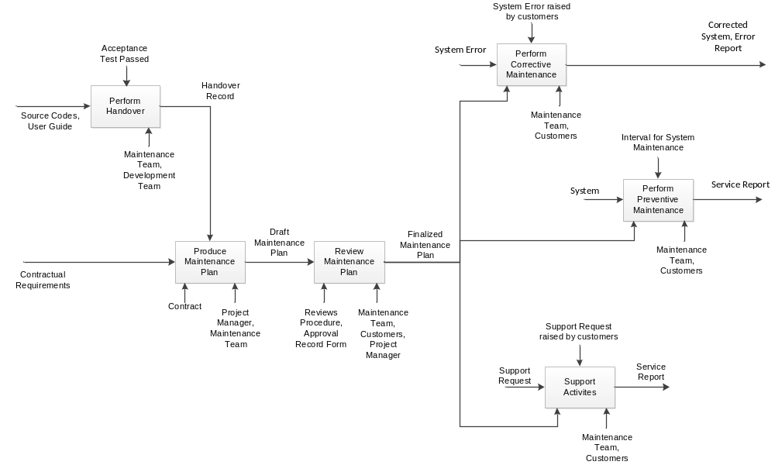

Perform Handover

The objective of this task is
- To allow the Development Team to handover the items that they have to the Maintenance Team.

Input | Source Codes, User Guide
Output | Handover record
Entry Criteria | Acceptance Test passed.
Process Flow | The Development Team performs a handover to the Maintenance Team when the Acceptance Test is passed and the project is about to transit from the Development phase to the Maintenance phase. The Development Team will hand over the Source Codes and User Guides to the Maintenance Team, and will train the Maintenance Team on the system.
Exit Criteria | Handover of the system from the Development Team to the Maintenance Team completed.
Resource | Maintenance Team  Development Team
Guidelines | -
Templates | -

Produce Maintenance Plan

The objective of this task is
- To create a draft version of the Maintenance Plan.

Input | Contractual Requirements
Output | Draft Maintenance Plan
Entry Criteria | Handover of system completed.
Process Flow | The Project Manager will create a draft Maintenance Plan based on the Contractual requirements for the maintenance phase.
Exit Criteria | Draft Maintenance Plan completed.
Resource | Project Manager  Maintenance Team
Guidelines | -
Templates | -

Perform Corrective Maintenance

The objective of this task is
- To diagnose and fix problems raised by the customers.

Input | System Error
Output | Corrected System, Error Report
Entry Criteria | System error raised by customers.
Process Flow | When a system error is raised by the customers, the Maintenance Team will diagnose the problem. After they have successfully diagnosed the problem, the Maintenance team will correct the system error. After correcting the error the Maintenance Team will then generate an Error Report for this incident.
Exit Criteria | System error corrected.
Resource | Maintenance Team  Customers
Guidelines | -
Templates | -

Perform Preventive Maintenance

The objective of this task is
- To perform regular maintenance tasks on the system to ensure the smooth operations of the system.

Input | System
Output | Service Report
Entry Criteria | Time for system maintenance.
Process Flow | The Maintenance Team will perform preventive maintenance tasks that will ensure the smooth running of the system.
Exit Criteria | Preventive Maintenance tasks completed.
Resource | Maintenance Team  Customers
Guidelines | -
Templates | -

Support Activities

The objective of this task is
- To provide support for the customers whenever required.

Input | Support Request
Output | Service Report
Entry Criteria | Support Request raised by Customers.
Process Flow | When the Customers raise a Support Request, the Maintenance Team will determine if they are able to provide the support required. If they are able to do so, they will carry on to provide the requested support. After the support they will then generate a Service Report for this support event.
Exit Criteria | Support completed.
Resource | Maintenance Team  Customers
Guidelines | -
Templates | -

